QueryLens:

A Validation-Aware SQL Query Analysis Tool for Performance Optimization

Parshotam Parmar
A00590956
COMP8047 Major Project
British Columbia Institute of Technology
Date: April 22, 2026

Contents
1. Introduction 3
1.1 Project Context 3
2. System Design 4
2.1 SQL Parsing and Feature Extraction 4
2.2 Static Analysis Engine 4
2.3 Execution Plan Analysis 4
2.4 Correlation and Validation Engine 5
2.5 Reporting and Artifact Generation 5
2.6 Alternative Approaches 5
2.7 Feasibility Assessment 6
2.8 Use of Technologies 6
2.9 Evolution of Deliverables from Proposal 7
3. Implementation 7
3.1 Static Analysis Implementation 7
3.2 Runtime Analysis Implementation 8
3.3 Correlation Engine Implementation 8
3.4 System Usage 8
4. Evaluation 9
4.1 Overall Performance 9
4.2 False Positive Reduction 9
4.3 Precision Improvement 10
4.4 Ground Truth Validation 10
4.5 Rule-Level Performance 10
5. Discussion 11
5.1 Strengths 11
5.2 Limitations 11
5.3 Future Work 12
5.4 Timeline and Milestones 12
6. Conclusion 13
7. Professional and Academic Development 13
8. Lessons Learned 14
Appendix A — Approved Proposal 14
Appendix B — Proposal Changes and Approvals 14
Appendix C — Change Log 14
References 15

1. Introduction
Modern database-driven applications depend heavily on efficient SQL query execution to ensure scalability and responsiveness. However, identifying performance issues in SQL queries remains a challenging task, particularly for developers who lack visibility into how queries behave at runtime. Traditional approaches to query analysis often rely on either static code inspection or runtime execution plan analysis but rarely integrate both perspectives in a unified framework.
Static analysis tools can identify common anti-patterns such as non-SARGable predicates, excessive data retrieval, and inefficient joins. However, these tools frequently generate false positives because they lack awareness of actual execution behavior. In contrast, execution plan analysis provides detailed insights into runtime performance but does not inherently explain the underlying causes of inefficiencies in the original SQL code. As a result, each approach offers only a partial view of query performance when used in isolation.
This project introduces QueryLens, a validation-aware SQL query analysis tool designed specifically for Microsoft SQL Server. QueryLens integrates grammar-based static analysis with execution plan evaluation to produce more accurate and actionable performance recommendations. By correlating static warnings with runtime evidence, the system reduces false positives and improves the reliability of optimization suggestions.
The motivation for this project stems from real-world experience working with SQL Server databases in a production environment, where inefficient queries and stored procedures frequently caused performance bottlenecks. Existing tools often produced noisy or incomplete recommendations, making it difficult to prioritize optimization efforts. QueryLens addresses this gap by combining static and runtime analysis into a single, coherent system.
The primary objective of this project is to demonstrate that integrating execution plan validation into static SQL analysis significantly improves precision and reduces false positive recommendations. Unlike conventional tools, QueryLens does not treat static and runtime analysis as independent processes but instead integrates them into a validation-aware framework that prioritizes confirmed inefficiencies over theoretical risks.

1.1 Project Context
QueryLens was developed in the context of SQL Server–based business systems where application performance is closely tied to database query quality. In transactional environments, small inefficiencies in query design can produce noticeable slowdowns when repeated across high-volume workloads. This project is especially relevant to operational systems such as point-of-sale platforms, where delays in transaction processing, reporting, or database access can directly affect users and business workflows.
The project is also grounded in practical industry experience. Performance issues observed in production SQL Server environments frequently originated from patterns such as unnecessary column retrieval, non-SARGable predicates, poorly selective joins, and inefficient report queries. Although SQL Server exposes detailed execution plans, interpreting those plans requires a level of database tuning expertise that is not always available to software developers or support analysts. QueryLens was therefore designed to bridge this gap by turning execution plan evidence into understandable, development-oriented feedback.
Within this operational context, the project addresses a real need: enabling earlier and more consistent identification of SQL performance risks before they escalate into production bottlenecks. QueryLens supports this goal by integrating static query inspection with runtime validation, allowing likely inefficiencies to be distinguished from confirmed performance issues.

2. System Design
QueryLens is implemented as a multi-stage analysis pipeline, where each component produces structured artifacts consumed by subsequent stages. This design enables traceability between static detections, runtime validation, and final recommendations.
The system consists of the following key components:

2.1 SQL Parsing and Feature Extraction
QueryLens uses an ANTLR-based T-SQL grammar to parse SQL queries into abstract syntax trees (ASTs). This grammar-aware approach enables accurate detection of query structures such as joins, subqueries, aggregations, and predicate expressions. A feature extraction module traverses the AST to identify relevant characteristics used for rule evaluation.

2.2 Static Analysis Engine
The static analysis component evaluates extracted features against a set of predefined rules representing common SQL performance anti-patterns. These include:
- Use of SELECT *
- Non-SARGable predicates (e.g., functions on indexed columns)
- ORDER BY operations without supporting indexes
- Complex joins and correlated subqueries
- Window functions and derived tables
Each detected issue is recorded as a structured finding with associated metadata and recommended optimizations.
QueryLens supports multi-rule detection, allowing a single SQL query to trigger multiple performance warnings, each independently validated against runtime evidence.

2.3 Execution Plan Analysis
Execution plans generated by SQL Server are parsed to extract runtime characteristics, including:
- Physical operators (e.g., Index Scan, Index Seek, Sort, Hash Match)
- Estimated row counts
- Join strategies and aggregation operations
These runtime features provide evidence of how queries are executed, enabling validation of static findings.

2.4 Correlation and Validation Engine
The core innovation of QueryLens lies in its correlation engine, which links static warnings to execution plan evidence. Each rule is classified as either runtime-verifiable or non-verifiable. For verifiable rules, the system evaluates whether execution plan characteristics support or contradict the static finding.
A confidence scoring mechanism assigns levels (high, medium, low, none) based on the strength of runtime evidence. Static findings that lack supporting evidence are suppressed, reducing false positives.

2.5 Reporting and Artifact Generation
The system produces a comprehensive set of artifacts, including:
- Structured JSON outputs for static and runtime analysis
- Evaluation metrics and correlation matrices
- False positive analysis logs
- HTML reports summarizing findings and recommendations
This layered output structure ensures transparency and facilitates further analysis.

2.6 Alternative Approaches
Several alternative approaches were considered before selecting the final design of QueryLens.
The first alternative was a static-only SQL analysis tool. This approach would examine SQL text for known anti-patterns such as SELECT *, functions in predicates, and complex joins, but would not consider execution plan behavior. A static-only solution would be simpler to implement and faster to run, but it would also produce a higher number of false positives because it would not be able to determine whether a detected issue affected execution behavior.
A second alternative was an execution-plan-only analyzer. This approach would focus entirely on SQL Server XML plans and operator-level behavior, such as scans, seeks, sorts, and joins. While this would provide strong runtime visibility, it would not explain the corresponding code-level source of inefficiencies. Such a system would be useful for database specialists, but less accessible to developers who need direct guidance about how to improve the original SQL text.
A third alternative was to rely on existing tools such as SQL Server Management Studio or standalone linting utilities. These tools provide partial support for performance analysis but typically emphasize either runtime diagnostics or code inspection rather than combining both in a single validation-aware workflow. They also tend to require significant manual interpretation and do not always prioritize issues according to supporting execution evidence.
For these reasons, the selected solution was a hybrid validation-aware analysis system. By combining static SQL analysis with execution plan correlation, QueryLens was designed to preserve the interpretability of code-level diagnostics while improving accuracy through runtime confirmation. This approach best aligned with the project’s practical objective of reducing false positives and producing more reliable recommendations.

2.7 Feasibility Assessment
The feasibility of QueryLens was evaluated in technical, operational, and schedule terms.
From a technical feasibility perspective, the project was practical because all core technologies were available and well supported. Python provided a flexible environment for pipeline orchestration and artifact generation. ANTLR supplied a mature grammar-based parsing framework for T-SQL analysis, and SQL Server execution plans could be exported in XML format for deterministic parsing. The modular nature of the problem also made the system suitable for staged development, beginning with simple static rule detection and expanding toward runtime validation and reporting.
From an operational feasibility perspective, the required environment was modest and already available. Development and testing were performed on a single workstation using SQL Server Developer Edition, local datasets, and pre-generated execution plans. No external infrastructure, cloud services, or production data were required. This reduced both risk and implementation overhead.
From a schedule feasibility perspective, the project was manageable because it could be divided into incremental milestones. Early weeks focused on execution plan parsing and dataset engineering, followed by static analysis, correlation logic, evaluation, and reporting. This staged approach made it possible to validate progress continuously and reduce the risk of major late-stage integration failures. Over the course of development, the project expanded from prototype components into a consolidated end-to-end system totaling approximately 397 hours of effort.
Overall, QueryLens was feasible because it addressed a clearly bounded problem, used accessible technologies, and could be implemented iteratively with measurable intermediate deliverables.

2.8 Use of Technologies
QueryLens incorporates several technologies that were selected specifically to support accurate, reproducible SQL performance analysis.
The first key technology is ANTLR, which was used to support grammar-aware parsing of T-SQL queries. Rather than relying only on regular-expression heuristics, the use of ANTLR allowed QueryLens to parse SQL into abstract syntax trees and inspect structural features such as joins, subqueries, HAVING clauses, window functions, and derived tables. This provided greater precision and extensibility in rule detection.
The second key technology is SQL Server execution plan analysis. QueryLens parses SQL Server XML plan files to extract runtime evidence including scans, seeks, joins, sorts, parallelism operators, and estimated row counts. This allows the system to move beyond purely theoretical warnings and instead assess whether static findings are supported by observed execution behavior.
The third important technical element is the system’s validation-aware correlation engine, which links code-level detections to execution-plan evidence. This correlation layer represents the main research and implementation contribution of the project because it enables selective confirmation, suppression, and confidence scoring of findings.
Finally, QueryLens uses structured artifact generation and reporting to ensure reproducibility. JSON, CSV, and HTML outputs are produced from the same core pipeline, making the system suitable both for experimentation and for end-user diagnostic reporting.
Together, these technologies support the project’s goal of producing a practical and evidence-based SQL performance analysis tool rather than a static linter or a plan viewer alone.

2.9 Evolution of Deliverables from Proposal
The original project proposal defined a set of core artifacts to support static analysis, execution plan parsing, and report generation. During implementation, these artifacts were refined and expanded to support validation-aware evaluation and reproducibility.
Several proposed artifacts were reorganized into a structured directory hierarchy to improve clarity and maintainability. For example, analysis outputs such as static_results.json and plan_results.json were moved into a dedicated artifacts/analysis/ directory, while evaluation outputs were grouped under artifacts/evaluation/.
In addition to restructuring, new artifacts were introduced to support the validation-aware design of QueryLens. These include correlation matrices, false positive validation logs, performance benchmarking outputs, and comparison artifacts demonstrating improvements over static-only analysis. These additions were necessary to provide empirical evidence supporting the project’s primary objective of reducing false positives and improving diagnostic precision.
The final system therefore extends the original proposal by not only generating diagnostic outputs but also producing a comprehensive set of evaluation artifacts that enable reproducible experimentation and quantitative analysis. These enhancements do not change the core objectives of the project but strengthen the evaluation methodology and improve the transparency of results.

3. Implementation
QueryLens is implemented in Python and follows a modular architecture to ensure maintainability and extensibility.

3.1 Static Analysis Implementation
Static analysis is performed using an AST-based approach rather than regular expressions, improving detection accuracy and reducing ambiguity. Unit testing confirms the correctness of rule detection across all supported patterns, with all tests passing successfully.

3.2 Runtime Analysis Implementation
Execution plans are parsed to extract operator-level details such as scans, seeks, joins, and sorts. These operators serve as indicators of query performance characteristics. For example, the presence of an Index Scan often indicates inefficiency when a seek could be used.

3.3 Correlation Engine Implementation
The correlation engine evaluates each static finding against runtime evidence. For example:
- A SELECT * warning is confirmed if scans and large row counts are present
- A missing WHERE warning may be suppressed if runtime evidence does not indicate inefficiency
- False positive logs demonstrate that several static warnings were correctly suppressed due to insufficient runtime evidence, improving overall accuracy.

3.4 System Usage
QueryLens is designed to operate as a batch analysis tool over a defined workload of SQL files and corresponding SQL Server execution plans.
To run the complete system, the user executes the main pipeline command:
python -m src.run_full_analysis
This command processes all SQL files in the plans directory, attempts to locate matching .sqlplan files, and then executes the following stages:
- static SQL analysis
- feature extraction
- execution plan parsing
- static/runtime correlation
- rewrite suggestion generation
- evaluation artifact generation
- report generation
The required input format is a pair of files for each workload item:
- a .sql file containing the query to analyze
- a matching .sqlplan file containing the SQL Server execution plan
The main outputs are written to the artifacts/ directory. These include structured analysis results in JSON format, evaluation metrics in JSON and CSV formats, and a human-readable HTML report. Additional proposal-traceability artifacts such as detection_results.json, correlation_matrix.csv, validation_log.txt, comparison_summary.csv, and combined_vs_baseline.png are also generated automatically.
This workflow allows the system to be reproduced from a single command and supports consistent experimentation across the benchmark workload.

4. Evaluation
The system was evaluated using a controlled experimental methodology designed to assess the effectiveness of validation-aware SQL analysis. A workload of 31 SQL queries was constructed to represent a range of realistic database scenarios, including joins, aggregations, subqueries, and indexing patterns. For each query, a corresponding SQL Server execution plan was generated and analyzed alongside static detection results.
Testing was performed using a reproducible batch pipeline that applies static analysis, execution plan parsing, and correlation-based validation across the entire workload. Evaluation metrics were derived by comparing static warnings against runtime evidence to measure confirmation rates, false positive reduction, and precision improvement. All experiments were executed using stored inputs and execution plans, ensuring consistency and repeatability of results.
The evaluation process produced structured artifacts including validation reports, correlation matrices, performance logs, and comparison summaries, which were used to support analysis and ensure traceability of results.

4.1 Overall Performance
The analysis produced 57 static warnings, of which 37 were runtime verifiable. Among these, 32 warnings were confirmed by execution plan evidence, resulting in a runtime agreement rate of 86.5%.
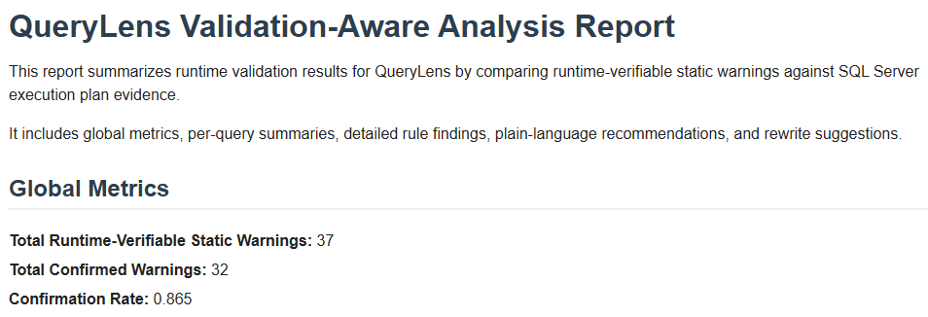
Figure 1: QueryLens runtime validation report showing per-query analysis results, validation status, and confidence levels.

4.2 False Positive Reduction
Static-only analysis generated a large number of false positives. By incorporating runtime validation, QueryLens reduced false positives from 57 to 20, representing a 65% reduction. This demonstrates the effectiveness of combining static and runtime analysis.

4.3 Precision Improvement
The precision of the analysis improved significantly when runtime validation was applied. Static-only analysis resulted in low effective precision in practice, highlighting the limitations of unvalidated static detection, whereas the combined approach achieved 64.9% precision, representing a substantial improvement in recommendation quality.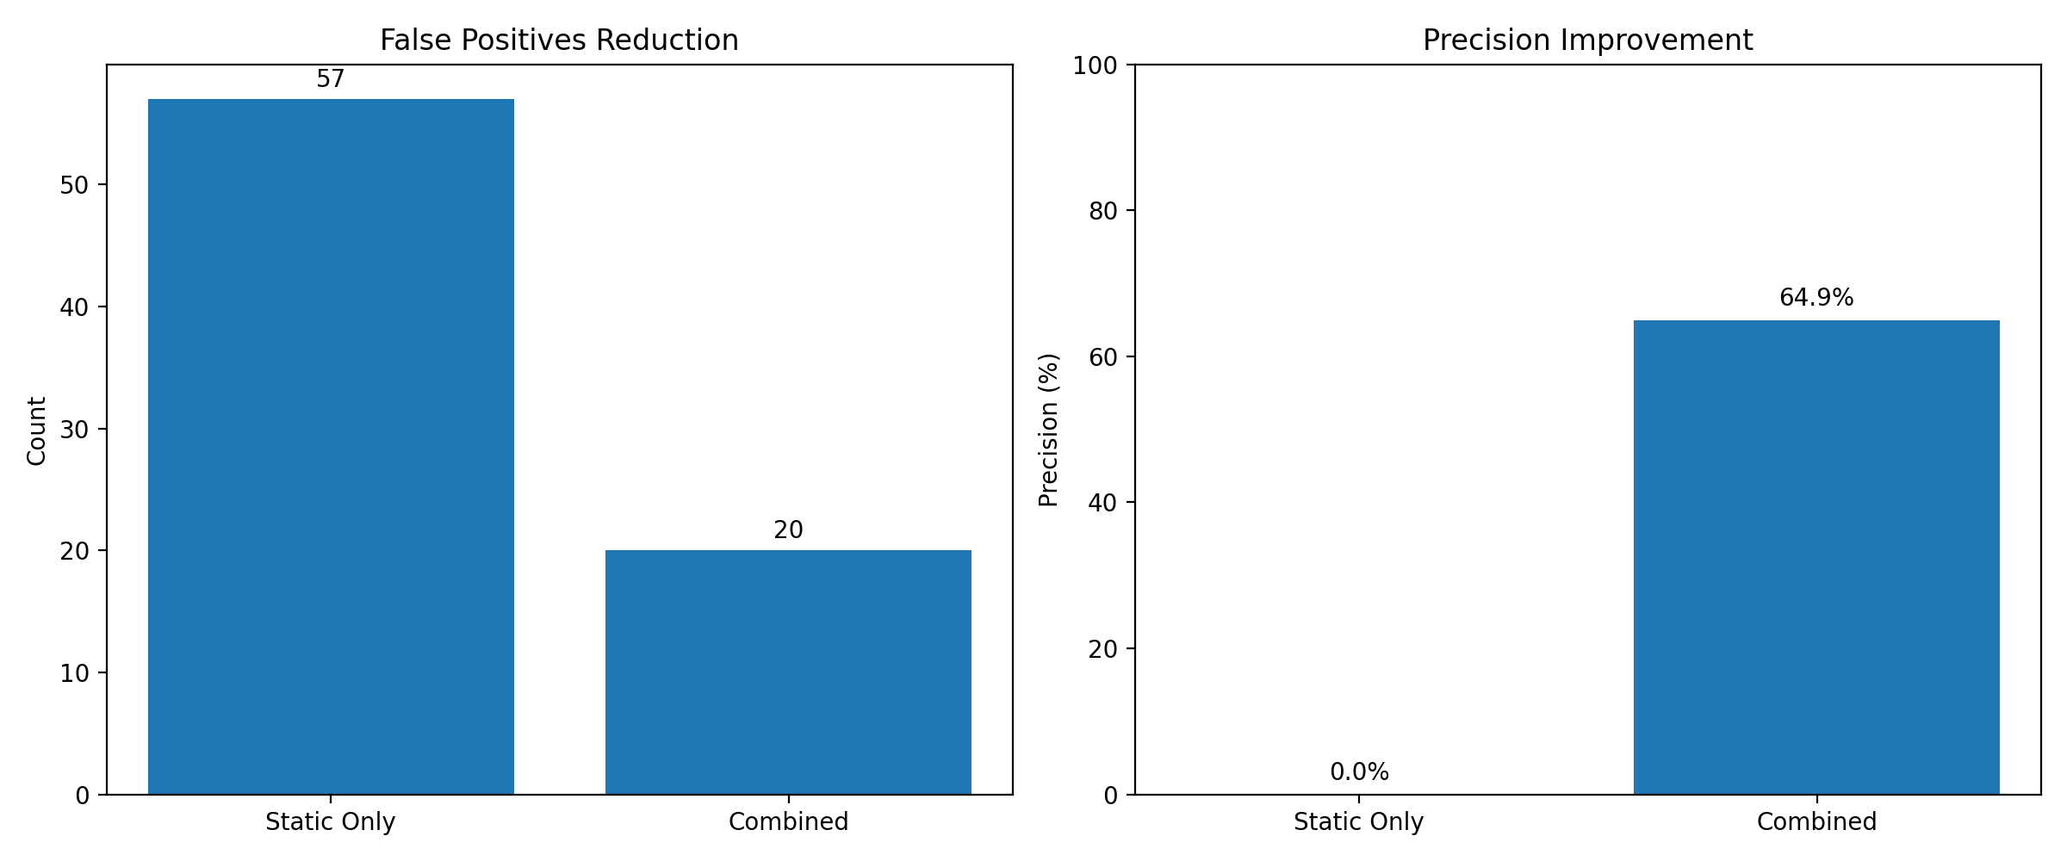
Figure 2: Comparison of static-only analysis and validation-aware QueryLens analysis, illustrating reduction in false positives and improved precision

4.4 Ground Truth Validation
When evaluated against a labeled dataset, QueryLens achieved exact performance on the labeled dataset:
- Precision: 1.0
- Recall: 1.0
- F1 Score: 1.0
These results are based on a controlled labeled dataset and reflect correctness of rule implementation rather than real-world detection completeness.

4.5 Rule-Level Performance
Certain rules demonstrated particularly strong performance:
- non_sargable_predicate: 100% precision
- order_by_no_index: 100% precision
- select_star: 90% precision
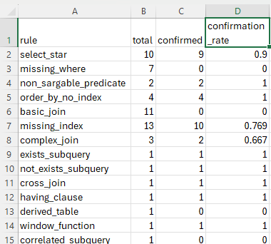
Figure 3: Rule-level correlation matrix summarizing confirmation rates between static detections and execution plan evidence.
In contrast, rules such as missing_where and basic_join were not runtime-verifiable and therefore required suppression logic to prevent misleading recommendations.

5. Discussion
The results demonstrate that integrating runtime validation into static SQL analysis significantly improves the quality of performance recommendations.

5.1 Strengths
The primary strength of QueryLens lies in its ability to reduce false positives while maintaining high detection accuracy. By grounding static findings in execution plan evidence, the system provides more reliable and actionable insights. The modular architecture and comprehensive artifact generation further enhance its usability and extensibility.

5.2 Limitations
Despite its strengths, the system has several limitations related to implementation scope and evaluation constraints.
First, QueryLens operates on pre-generated SQL Server execution plans rather than establishing a live database connection. Execution plans are exported externally and then analyzed offline. While this approach ensures reproducibility and simplifies the evaluation process, it limits the system’s ability to dynamically capture runtime behavior directly from a live database environment.
Second, the system relies on estimated execution plan metrics rather than actual runtime statistics such as actual row counts and execution frequencies. Although estimated values are sufficient for identifying many performance characteristics, they may not fully reflect real execution conditions under production workloads. This restricts the ability to validate performance issues that only emerge under real runtime variability.
Third, the evaluation methodology focuses on agreement between static analysis and execution plan evidence rather than absolute ground truth correctness. Comprehensive ground truth labeling for all possible SQL inefficiencies is not feasible, and therefore the system evaluates consistency and correlation rather than definitive correctness.
Finally, the dataset used for evaluation is synthetic, although designed to reflect realistic SQL Server workloads. While it captures a wide range of query patterns, it does not fully represent the complexity and variability of large-scale production systems.
These limitations reflect deliberate design trade-offs made to ensure feasibility, reproducibility, and controlled evaluation within the scope of the project.

5.3 Future Work
Future improvements could include:
- Expanding the rule set to cover additional SQL patterns
- Incorporating cost-based analysis using execution plan metrics
- Extending support to other database systems
- Integrating machine learning techniques for adaptive rule weighting

5.4 Timeline and Milestones
The development of QueryLens followed an incremental milestone-based schedule that allowed core components to be implemented and validated progressively.
The first phase focused on environment setup, execution plan parsing, and dataset preparation. This established the technical foundation of the project by configuring SQL Server, Python tooling, and the initial plan-analysis prototype. It also produced the baseline workload and seeded datasets required for later evaluation.
The second phase focused on static SQL analysis and parser integration. During this stage, the original heuristic analysis was refactored into a grammar-aware pipeline using ANTLR, and automated testing was introduced to validate rule detection.
The third phase emphasized runtime validation and evaluation design. This included development of the static/runtime correlation engine, generation of correlation metrics, false-positive diagnostics, and HTML reporting.
The fourth phase extended the project through expanded workload evaluation, rule refinement, and architectural consolidation. The benchmark workload was increased to 30+ queries, runtime confirmation logic was refined, and the evaluation workflow was standardized around the final validation-aware pipeline.
The final phase focused on recommendation generation, proposal traceability, and submission readiness. During this stage, rewrite suggestions were integrated, proposal-supporting artifacts were regenerated from the main pipeline, and the repository structure, documentation, and reporting outputs were finalized.
This milestone structure made it possible to progress from a narrow prototype into a fully integrated and reproducible analysis system while continuously validating intermediate results.
The development timeline is further supported by version-controlled commit history, where each milestone corresponds to a recorded weekly commit documenting implemented features, evaluation changes, and system refinements.

6. Conclusion
QueryLens demonstrates that combining static SQL analysis with execution plan validation provides a practical and effective approach to query performance optimization. The system successfully reduces false positives, improves precision, and delivers more reliable recommendations compared to static analysis alone.
By bridging the gap between code-level analysis and runtime behavior, QueryLens offers a valuable tool for developers and database administrators seeking to optimize SQL performance. The results of this project confirm that validation-aware analysis is a promising direction for future research and development in database performance tools.
This work demonstrates a practical and scalable approach to SQL performance analysis that can be extended to real-world development environments.

7. Professional and Academic Development
This major project significantly strengthened expertise in the database specialization by connecting theoretical concepts from coursework to the design of a practical software system. The project required applied use of SQL optimization principles, execution plan interpretation, parser design, rule-based analysis, evaluation methodology, and structured reporting. Through QueryLens, concepts such as non-SARGability, indexing strategy, join selectivity, and runtime operator behavior were translated from classroom topics into an implemented tool with measurable results.
The project also extended skills beyond traditional coursework by requiring the integration of multiple technical domains into a single end-to-end system. This included grammar-based parsing with ANTLR, structured artifact generation, experimental benchmarking, and evaluation of detection quality using both labeled datasets and runtime validation evidence. As a result, the project strengthened both technical specialization and systems-level design thinking.

8. Lessons Learned
Several lessons were learned during the development of QueryLens beyond what is typically covered in classroom exercises.
The first lesson was that accurate diagnostics require more than correct detection logic. Early static analysis components could successfully identify common SQL anti-patterns, but without runtime context they also produced unnecessary warnings. This reinforced the importance of evidence-based validation rather than relying solely on heuristic pattern matching.
The second lesson was that software architecture matters as much as algorithm design. As the project expanded, modularization, artifact organization, and pipeline consolidation became essential to keeping the system maintainable and reproducible. Refactoring and standardization were therefore not secondary cleanup tasks, but core parts of completing the project successfully.
The third lesson was that evaluation design is itself a major engineering task. Building a reproducible benchmark workload, generating comparable execution plans, constructing ground-truth datasets, and producing report-ready artifacts required substantial effort and careful methodological choices. This experience demonstrated that high-quality software projects depend not only on implementation, but also on the quality and transparency of their validation process.
Finally, the project reinforced the practical value of building systems around real operational problems. By grounding the work in realistic SQL Server performance issues, QueryLens became more than an academic prototype; it became a focused demonstration of how database expertise, software engineering, and evaluation discipline can be combined into a useful diagnostic tool.

Appendix A — Approved Proposal
A copy of the approved major project proposal should be included here.

Appendix B — Proposal Changes and Approvals
The core objectives of the project remained consistent with the approved proposal. However, several implementation refinements were introduced during development, including artifact restructuring, evaluation pipeline consolidation, and expansion of proposal-supporting outputs to improve reproducibility and evaluation transparency.

Appendix C — Change Log
Version | Date | Change Summary
1.0 | April 22, 2026 | Initial full draft of final report
1.1 | April 22, 2026 | formatting, evaluation clarification, guideline alignment

References
Microsoft. Display an Actual Execution Plan. Microsoft Learn.
Grant Fritchey. SQL Server Execution Plans.
ANTLR grammars-v4 repository. T-SQL Grammar.
Python Software Foundation. Python Documentation.
Microsoft. SQL Server Query Processing Architecture Guide.

